What are thoughts?
Humans are very good at telling stories. We use words to symbolize simple and complex things. In public, we use words when we talk, listen, read, and write. In private, we use words inside our heads—we call these “thoughts.”
Thoughts are like newspaper stories. We know that newspaper stories are biased—they give us one angle of the event that reflects the editorial philosophy of the paper. They can be more or less accurate, more or less complete, more or less biased. No matter where a newspaper story falls on these spectrums, the story is not the actual event. When you read a newspaper story about a bank robbery, the robbery isn’t happening right here, right now.
We also know that at any point, we can stop reading a newspaper story. If we’re not getting anything useful from it, we can simply put it down and do something else.
When it comes to our own thoughts, it may be less obvious that these stories are not the absolute truth, or that we don’t have to give them our full attention. When we react to our thoughts as if they were the actual event (or truth), we call this reaction “fusion.”

What is “Fusion”?
In a state of fusion, it seems as if:
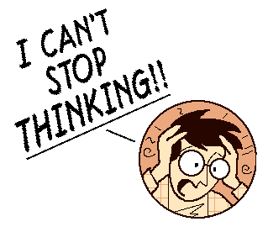
Thoughts are reality—what we’re thinking is actually happening, here and now
Thoughts are the truth—we completely believe them
Thoughts are important—we take them seriously and give them our full attention
Thoughts are orders—we automatically obey them
Thoughts are wise—we assume they know best, and we follow their advice
Thoughts can be threats—some thoughts are deeply disturbing or frightening, and we feel the need to get rid of them

What if we learned to defuse our thoughts?
“Defusion” means pulling the thought away from the actual event so that they are not stuck together as if they were one and the same. It does not mean getting rid of the thought or changing the thought, but simply to see it as what it is—a string of words.

In a state of defusion, we recognize that:
Thoughts are merely sounds, words, stories, or bits of language
Thoughts may or may not be true; we don’t have to automatically believe them
Thoughts may or may not be important; we only pay attention if they’re helpful
Thoughts are definitely not orders; we don’t have to obey them
Thoughts may or may not be wise; we don’t automatically follow their advice
Thoughts are never threats; even the most painful or disturbing of thoughts does not represent a threat to us, because they are stories about reality, they are not reality itself.

To defuse thoughts, try:
- Labeling
“I’M HAVING THE THOUGHT THAT…”
Choose an upsetting thought and focus on it as much as you can for 10 seconds. Then, insert the above phrase before that thought. This allows you the step back and see this thought for what it is: words passing through your head.
- Making it musical
Bring to mind a self-judging thought that bothers you. Hold it in mind and believe it as much as you can for 10 seconds. Now, take that thought and sing it to yourself to the tune of “Happy Birthday.” Notice what happens. Are you taking it as seriously or buying into it as much as before? Notice that you haven’t challenged or wrestled with the thought at all—you haven’t debated if it’s true or false, replaced it with a positive thought, or gotten rid of it. You’ve “defused” it by realizing that it’s just made up of words, like the lyrics of a song.
- Naming your story
“Oh look, it’s the ____ story!”
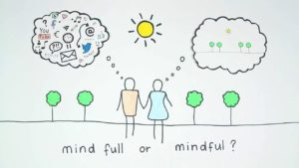
Identify your mind’s favorite stories, the give them names (e.g., the “I can’t do anything right” story). When your stories show up, acknowledge them by name—“Aha, that’s an old favorite…the ‘I’m unworthy’ story!” Once you’ve acknowledged the story, don’t fight it. Just let it come and go as it pleases while you channel your energy into something you value.
***Remember, negative stories themselves are not a problem in their own right—our minds tell stories all the time, and often they tell negative stories. It’s only when we “fuse” with these stories, reacting as if they were the absolute truth and giving them our full attention, that they become problematic.

